Communication

General

Two independent communication streams allow to read and write data to the PSC, an overview is given in Fig. 2 . The optical serial in- and output are designed for the connection to the control system and will therefore often be referenced to as 'CONTROL' or 'CIO'. The second serial connection corresponds to the RS232 standard. Both channels have a very similar structure and share most of the VHDL-entities, which are instantiated twice. Differences will be mentioned at the corresponding places throughout the following sections.
Bytes are asynchronously transmitted in the sequence 'start bit - 8 data bits - parity bit - 1 stop bit'. The parity bit is checked for every byte.

Link Specification
The communication has been defined in the 'memorandum' Error: Reference source not found, the main points will be repeated here in sections 1.2.1 through 1.2.5.

Block structure
- The communication is always organised in identical blocks as shown in Fig. 1. Each block starts with a 'preamble', followed by status byte and address byte. Following are 32 bit of data transmitted in four bytes. The length of a block with preamble, start, parity and stop bits is 78 bits. In all cases bytes have to be transmitted atomic (to improve the quality of the error detection.)
- Preamble: The preamble identifies the begin of a new block. Its data corresponds with the data in the idle state of the transmission. The preamble is a 'high' signal for the duration of 12 bits or longer.
- Status byte: The 8 bits are used as follows:
- spare
- spare
- 0: link ok; 1: link down
- 0: PS controlled by the control system; 1: PS controlled local (RS232-port)
- 0: DSP running; 1: DSP stopped
- 0: input buffer not full; 1: input buffer full
- write cycle / read request; 1: write-echo / send of requested data.
- 0: read cycle; 1: write cycle;
- Address byte: The address of the data is specified by the 8 bits which allows the addressing of 255 read and write channels ('registers').
- Data word: Every data word consists of four times 8 bit, i.e. 4 bytes. In a read request the content of the 4 downloaded bytes will be neglected (in the present).
- Break: No signal on a link for more than 30 bits is interpreted as a break of the link. If this case is detected it is communicated to the other side with an error bit in the mode/status byte. In this case the slave writes to the master without being asked. The remaining 5 bytes will send back address and content of memory location 0. Sending of this block is repeated until signal is detected
- Start, stop and parity bits: The sequence in each byte is a start bit (logical 0), LSB...MSB, a parity bit (odd parity) and it ends with a stop bit. It is the common structure of the recommended standards.

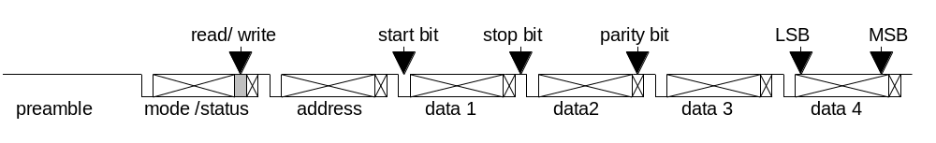
Fig. 1: Block structure of the serial communication streams.

Loop back, auto echo
Written data are echoed by the receiver byte by byte with start, parity and stop bits (not bit by bit!). This allows the sender to perform a check of the correct transmission.
A read request is not echoed. It is answered by the address of the requested data and the data itself. In the updated status byte, bit 6 is set. The writing of the answer can already begin while the transmission of the read request is still in progress (data bytes of the read request are not used, but checked!)
Every write or read cycle has to be terminated before starting a new one.

Data check, error detection
Every byte has to be checked with the parity bit. A detected parity error leads to abortion of the whole data by the receiver. After detecting a parity error the receiver will send a start bit only to the sender. After that the link goes to the idle state for at least 12 bits, respectively until it receives a new preamble. This sequence can be detected as a parity error together with a block end.
Data high for more than the length of the preamble (12 bits) within a block are interpreted as the begin of a new block. The incomplete block is discarded.
Data low for more than 30 bits are interpreted as a break of the link. In this case data block described in section 1.2.1is sent to the master.
An additional check can be done by the sender with the echoed data. Data sent after a read request can be verified with the parity check. This leads to a high reliability of the link.

Master slave structure
Though the communication has to be identical for both directions the EPICS VME crate shall be the master of the communication in the present.

Biphase modulation
To avoid distortions at high baud rates, caused by dc components in the signal, differential biphase level (Manchester encoding) is applied at the 5 MHz baud rate. (On the power supply this differential biphase level can be activated for every baud rate).

VHDL implementation – general comments

Serial data
Communication with the control system proceeds via optical fibres and runs at 5 MBaud. In addition, the standard frequency of 115.2 kHz as well as the two- four- and eightfold of that speed are selectable. Biphase- (Manchester-) modulation can be activated for every frequency. Modulation at 5 MHz is standard. (See Error: Reference source not found on how to select the different communication modes.)

 | CIO, ‘inv = ‘1’’ (standard) | CIO, ‘inv = ‘0’’ (non-standard) | RS232
Freq (kHz) | 115.2 / 230.8 / 461.6 / 923.2 / 5000 | 115.2 / 230.8 / 461.6 / 923.2 / 5000 | 115.2
‘Idle’ signal on link, no modulation | Light | Dark | High
‘Idle’ signal on link, modulated | Light-Dark | Dark-light | -
Startbit signal on link, no modulation | Dark | Light | Low
Startbit signal on link, modulated | Dark-light | Light-Dark | -
FPGA input signal / idle value / idle modulated | control_nRX / ‘0’ / ‘01’ | control_nRX / ‘1’ / ‘10’ | RS232_RX / ‘1’ / -
Synchronised signal / idle value / idle modulated | control_RX_60 / ‘1’ / ‘10’ | control_RX_60 / ‘1’ / ‘10’ | RS232_RX_30 / ‘1' / -
Manchester decoded input signal / idle value | dec_control_RX / ‘1’ | dec_control_RX / ‘1’ | - / ‘1’
Output signal before Manchester encoding is applied / idle value | dec_control_TX / ‘1’ | dec_control_TX / ‘1’ | RS232_TX / ‘1’
Encoded output signal / idle value / idle modulated | control_TX_int / ‘1’ / ‘10’ | control_TX_int / ‘1’ / ‘10’ | - / ‘1’
Output signal after inversion / idle value / idle modulated | control_TX / ‘1’ / ‘10’ | control_TX / ‘0’ / ‘01’ | RS232_TX / ‘1’
‘Idle’ signal on link, no modulation / modulated | Light / Light-Dark | Dark / Dark-Light | High / -
Table 1: Signal levels and selectable parameters on link and FPGA for the different inversion settings.

Block structure
On top of the byte-structure, communication proceeds via 6 byte blocks with the structure 'status byte - address byte - 4 data bytes'. Per default, every block received by the PSC is echoed by an according block - the status byte is updated and in case of read commands the requested data is sent. In case of write requests, the data bytes written to the PSC are simply echoed. The address is always echoed unless an illegal command to the FPGA was received. If any of the bytes of a block is received with wrong parity, the whole block is aborted and the echo stops indicating the error to the communication master. Echoing by the PSC can be suppressed, if the ‘echo on’ bit (see Error: Reference source not found) is set to ‘0’.

Master function
The PSC acts as slave in the communication. It can be set to be master (only for the CIO channel, not for RS232), if the ‘PSC is master’ bit (see Error: Reference source not found) is set to ‘1’. If this is the case, the DSP can write 32-bit data to the ‘Comm. Master Data’ address (see Error: Reference source not found), followed by the 8-bit address byte, which is to be written to the ‘Comm. Master Addr’ address and which releases the sending of that block. Reading at the same address tells the DSP in master function, whether the sender is busy of not.

Write priority
While both channels can be used for reading in parallel, the writing-priority is assigned to only one of them at the time. If no PC is connected via the Dsub connector on the front panel of the controller card (RS232 unused, RS232_CHK low), write priority is always with the CIO. If the RS232 interface is connected to a PC through the appropriate cable, RS232_CHK is pulled high and the priority can be requested (only from the RS232 IF) by writing a ‘00000001’ to byte 3 address 2 (Priority RS232 in Error: Reference source not found). Priority can be handed back to the CIO either by writing ‘0’ from the RS232 to the above address or by simply unplugging the Dsub connector. The CIO cannot influence the priority setting.

Address space seen from the serial links
Depending on their address, read and write commands access data on the FPGA or on the DSP. The address-space 0x0 to 0x3 seen from the serial links correspond to registers on the FPGA (see Error: Reference source not found), addresses 0x4 to 0xFF are not recognised by the FPGA but correspond to registers on the DSP where the subrange 0x04 to 0x1F is reserved for the parameters which can be written from the DSP to the FPGA and the address range 0x20 to 0x2F is reserved for commands to the monitor or user program. E.g. a read command to address 0x16 will not report the value of SYNC_PHASE_MIN used in the FPGA, but its mirrored value on the DSP (see sections 1.5.4 and 1.5.5).

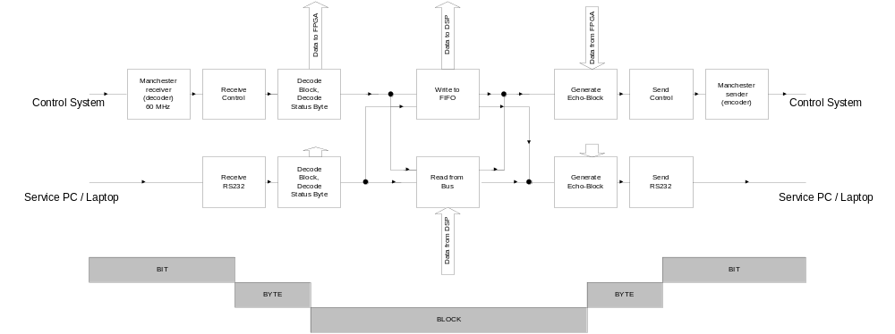
Fig. 2: Data flow serial communication. Serial bit-streams are received as bytes which are combined to blocks. When forming the answers, blocks are split into bytes which are transmitted bit by bit.

VHDL entities serial communication

Clock divider
All strobe signals necessary for the serial communications are obtained from dividing the 30/60 MHz clocks. Two versions of the clock-divider exist, clock_div_var (generates signals for varying transmission frequencies according to the set-up of the communication with the control system) and clock_div_rs232 (generates strobe signals for to 115.2 kHz only). Allowing much more flexibility, the variable frequency version of course occupies more resources of the FPGA and has therefore only been implemented for the communication with the control system.

Four steering signals are generate by the divider function:
- strobe_serial_send: Strobe, active once for 33.3 ns per bit to send.
- strobe_manchester: Active 10 or 12 times for 16.7 ns per bit.
- sync_serial_rec: Oversampling strobe, active 5 or 6 times (33.3 ns) per bit.
- mod_man: Modulation for manchester sender. The signal is high for half the time of a bit and low for the other half.

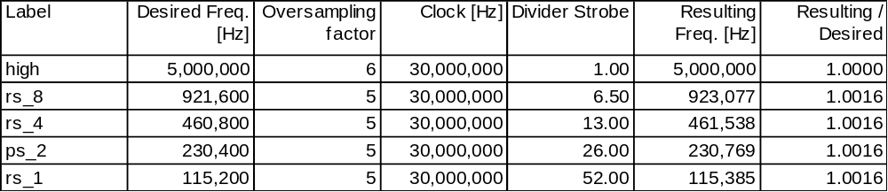
Tab. 2: Division factors for generating strobes of serial communication

For the 'high' case (5 MHz), six-fold oversampling can easily be achieved using the 30 MHz clock. If biphase modulation is used, the input data sampled at 60 MHz, allowing to have 6 samples of each of the two phases.

For the 'rs_1' case (115.2 kHz) five-fold oversampling can be done using an additional strobe active every 52 (=4*13) clock cycles. A bit therefore corresponds to 5*52=260 CC. To generate the mod_man signal, this time needs to be divided in two - one half of a cycle is 5*2*13=130 CC. All the other 'rs_x' cases are achieved similarly by further dividing all intervals by 2, 4 and 8 respectively. However it is obvious, that for the 'rs_4' and the 'rs_8' this is not possible within the given grid of the 30 MHz clock. A further division of the factor 13 into 4 more or less equally long sub-periods is done by an internal signal, which is active whenever the counter (running from 0 to 12) is at 0, 4, 7, and 10. In this way the 13 CC interval is split into one 4 CC and three 3 CC intervals. As for every external signal a series of these intervals is linked together, the differences in the duration of the sub-periods are averaged.
Most of the counters are implemented as state machines. Certain divisions are to be executed twice, once for the 30 MHz clock and once for the 60 MHz clock.

Synchronisation of input and reset, inversion of input or output
The incoming serial bit streams are synchronised once at 30 and once at 60 MHz (CIO only) in the entity sync_serial. In addition, inversions of the signals may be applied in this entity. The signal from the optical receiver is 'low', when light is being received. At the beginning of the development it was defined, that the idle state of the serial lines should correspond to 'high' and 'light on' (which would make it easy to distinguish between 'idle' and 'no connection to a sender'.) In this case, the input of the CIO has to be inverted. Using a standard RS232 to optical converter card, it was found that the idle state ('high') corresponds to 'dark'. In this case, the output rather then the input of the PSC has to be inverted which can be chosen setting the ‘inv’ bit as defined in Error: Reference source not found to ‘1’. (Be aware of the fact, that in this case a break of the optical connection cannot be distinguished from the line being idle.)
In addition to the input data the reset signal is synchronised in this process. This is done such, that an incoming reset is fed asynchronously to the entire FPGA. The transition of the reset signal to the passive ('1') state is done synchronous with the clock signal.
See Table 1.

Manchester decoder
In ref. Error: Reference source not found it was defined, that communication with the control system uses manchester encoding (‘biphase level’) in order to avoid DC effects, if the LED of the optical link is permanently on in case of no active communication. The implemented encoding uses the standard given in Tab. 3. A long sequence of logical ‘1’ (link idle) corresponds this way on the optical link to a digital signal oscillating at 5 MHz, avoiding DC effects.

Un-encoded signal | Duration per bit | Encoded signal | Duration per ‘half-bit’
‘1’ | 20 ns | ‘10’ | 10 ns
‘0’ | 20 ns | ‘01’ | 10 ns
Tab. 3: Manchester encoding: a logical one is encoded as the sequence of a logical one followed by a zero. A logical zero is encoded accordingly.
rec_manchester, the first logics element in the serial data stream 'de-modulates' the incoming biphase modulated data and generates serial data. The entity is only present in the CIO stream; if no modulation is needed (do_manchester is low), the data is simply fed through.
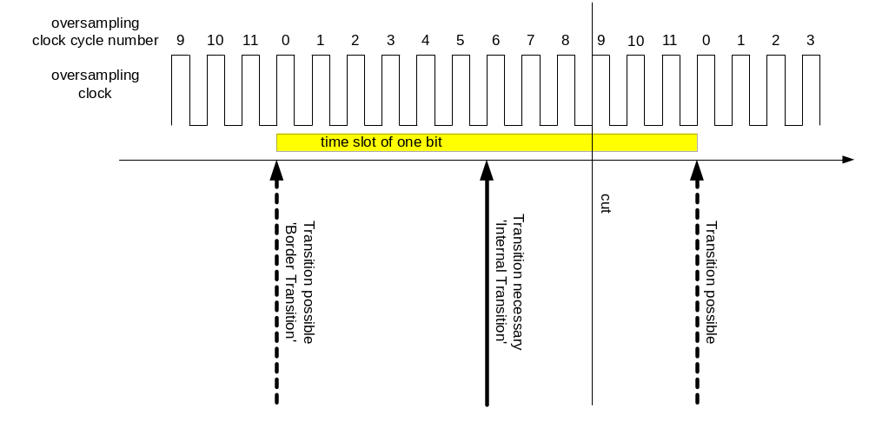
Fig. 3: A bit is 12 CC long, transitions may occur at start and end of the bit. In the centre of the bit, there is always an additional transition.

The idea behind the decoder is the following: One bit corresponds to 12 CC of the 60 MHz clock. By definition, there is always a transition of the input signal in the middle of the bits ('Internal Transition'), in addition there may be transitions at the beginning and at the end of the bits ('Border Transitions', depending on whether the un-encoded signal changes or not). To decode the input, we need to identify the transitions of the signals and count the number of clock cycles to the following transitions. Of course we first don't know, whether we start with a 'boarder transition' or with an 'internal' one. When starting with an internal transition, we always must see another transition after approximately 12 CC. If no transition follows after 12 +/- 2 CC, we know that we have started with a 'border transition' and therefore simply wait for the next transition which in turn must be an internal one.
According to the specification of the communication, not more then 9 zeroes may follow each other. If the counter starts on a wrong transition, it will misinterpret an idle-state of the sender as a sequence of zeroes instead of a series of ones. The number of decoded zeroes following each other is therefore counted and if it reaches 12, a phase shift of the decoder is done.
On the physical board, delays for falling and rising edges are different. If a transition occurs more then 9 CC after the start of the counter, it is considered as 1 entire bit later whereas earlier transitions are considered to be half a bit after the start. The maximal delay difference between rising and falling edges for which receiving works therefore is 2 CC i.e. 33ns (tested in simulation).
As the clocks of sender and receiver are of course only approximately synchronous, the counter does not turn over after 12 CC but is reset to zero by the detected transition.
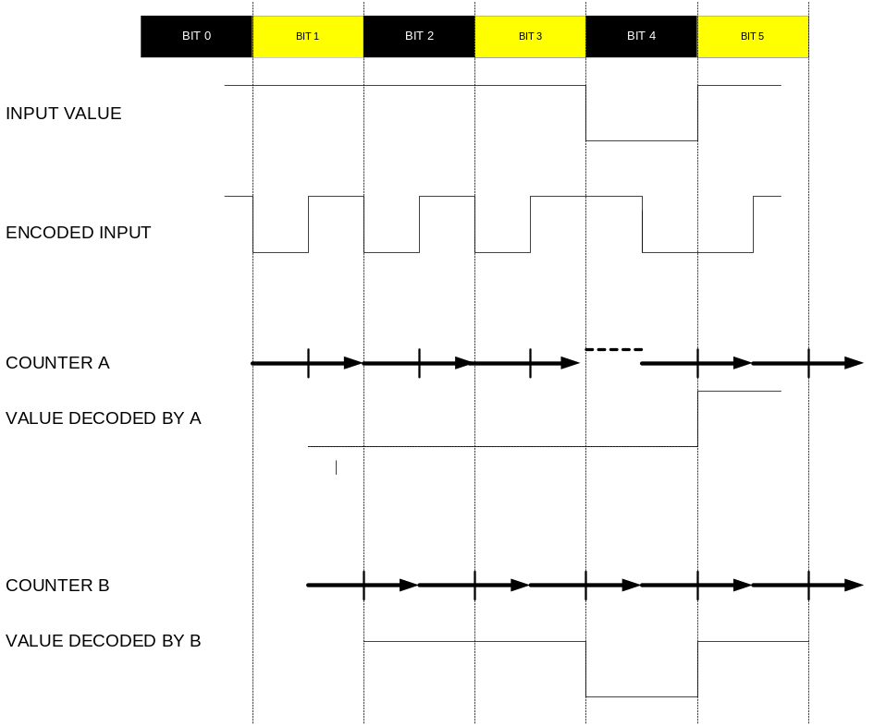
Fig. 4: Manchester Encoding: Input value and encoded signal. Two counters are started at different transitions for illustration of the decoding process: Counter A misfortunately starts on a 'border transition'. As the input value changes, there is no transition at the bit border and the phase of the counter is shifted by half a bit. Now both counters have the same phase and deliver correct output.

Serial receiver
The serial receiver can be used for 5-fold and for 6-fold oversampling. It consists of four processes:
- receiver: Main state machine according to the byte structure.
- counter_gen: Counter for oversampling strobes.
- strobe_gen: Generates the internally used sampling strobe once per bit.
- lat: Delays the output strobe 'newbyte_received' by one CC.
At reset, the state machine of the receiver is in the 'rxstartbit_state'. When the input data has the value 'STARTBIT', the receiving of a byte is started. As soon as the receiver is in the next state, the counter is enabled and will be incremented with every strobe - turn-over is after 5 or 6 strobes, depending on the selected oversampling factor. The sampling is controlled by the 'int_strobe' which is generated by the 'strobe_gen' process whenever the counter reaches the value of 2.
The selection between 5 fold and 6 fold oversampling is done by the signal five_fold which is determined in the entity clock_div_var from the selected transmission frequency. As for the receiver of the service interface (RS232) only five fold oversampling is necessary, the value of five_fold can be ignored in this instantiation of the receiver, which is implemented with the help of the generic constant ignore_five, which - somewhat confusing in the naming - selects five fold oversampling, ignoring the value of five_fold.

Serial sender
The serial sender consists of a state machine according to the structure of the bytes. No timing considerations are necessary here, everything is provided by the sync_serial_send strobe signal.
If the parity_ok signal goes low, this will be recorded by the signal do_rep_parity_ok which in turn is copied to rep_parity_ok when sending of a byte starts. do_rep_parity_ok is reset when transmission of a byte starts. If a parity error has been recorded before a byte is sent, only a startbit and 10 stopbits will be sent. 12 stopbits are required for this case in ref. Error: Reference source not found. There is no contradiction between this requirement and the implemented solution as after these 10 stopbits at least a preamble - maybe even more idle states - follow.
If the send_preamble bit is high, a preamble will be sent instead of a byte. The length of the preamble is adjustable by the constant Num_PREABITS. Keep in mind, that counting starts at 0.

Manchester encoder
Manchester encoding is very easy thanks to the mod_man signal which changes its value every half bit. As delay differences relative to the timing of the serial sender occur at the different possible frequencies, the serial input data is sampled once per bit, on the rising edge of mod_man.

Break- and preamble-detectors
Two special codes apart from the byte structures are defined for the communication:
- A BREAK of the optical link is detected, when no light is received for more than the duration of 30 bits. The entity break_detect is directly fed by the synchronized input data, before biphase decoding is applied. Keep in mind that a break can of course only be detected if the idle state of the communication differs from the signal which is received in the case of missing connections. This makes it impossible to detect breaks of the RS232 interface (where the signal RS232_CHK has been introduced to check whether a cable is connected to the card or not) or on the CIO if no biphase modulation is activated and the idle state is defined to be 'dark' (non-standard setting). Break detection is applied to the non-decoded (‘raw’) input signal.
- A PREAMBLE is detected, if the decoded value of the input stream is '1' for more than 12 bits and indicates that the communication link is presently idle. Preamble detection is applied to the decoded input signal.

VHDL entities handling communication blocks
The received bytes have to be combined to the defined block structure. Depending on the address and on whether it is a read or a write command, the requested echo has to be formed and commands to the FPGA have to be recognised and executed. This task has been split into the three entities as described in the following.

Decode block, count communication errors
block_decoder: recognises the structure of the block (preamble, status, address, 4*data) and generates a globally available signal (byte_id) which indicates the position of the last received byte to all other entities. In addition, deviations from the expected block structure are recognised as errors and all errors in the CIO are counted.
- par_err: parity error detected by the serial receiver.
- bre_err: break of the CIO input line.
- pre_err: 'preamble' or 'block structure error'. Occurs, if a preamble is received during an incompletely transmitted block or if more then 6 bytes are received without the necessary preamble in between.
- fifofu: 'FIFO full': the FIFO for data to be written to the DSP (see section 1.5.4) is full i.e. the DSP cannot cope with the amount of written data any more. The counter is incremented once when the FIFO is filled completely and does not count e.g. the number of additionally received words which could be stored any more.
It is of course possible, that one error is counted several times, e.g. a line break may be counted as 'brea', 'parity error' and as block structure error (preamble error) if the connection is interrupted during transmission of a block.

In addition to incrementing the error counter, flags are set in case of new errors, telling the DSP that its connection to the controlling system is not reliable:
- FLAG 8: 'NEW BREAK ERROR': The break signal has become active, i.e. no information from the CIO is received any more. This is a serious error.
- FLAG 9: 'NEW COMMUNICATION ERROR': any of the other error signals (preamble, parity or FIFOFU) went active. These errors should not be fatal.

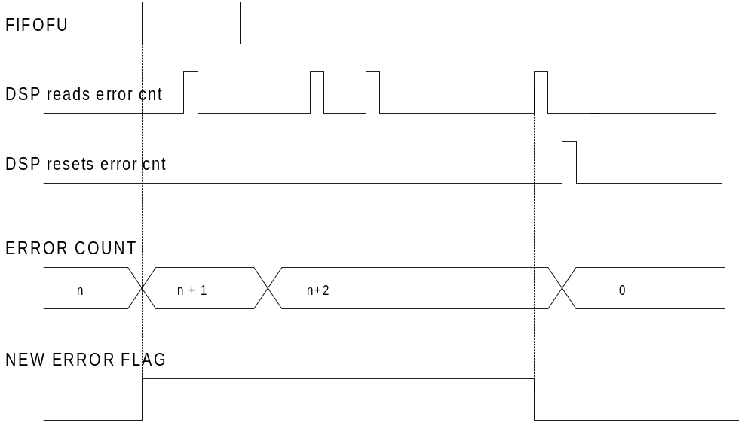

Figure 1: Reactions of error counters and new error flags to error signals and read / reset commands from the DSP.

Decode and update status byte
‘Status_decoder’:
- decodes the status byte, defines the variable read_command
- updates the status byte for the echo
- decodes in addition addresse byte and derives the signal echo_type (e.g. write_trigger or read_from_bus)
- executes commands to the FPGA (except trigger-signals from the serial IOs)

Generate echo
According to the received address and status bytes an echo has to be formed in gen_echo. Status and address are always received from the status decoder. The data bytes may originate from the status decoder (write commands), from some FPGA registers (read FPGA status) or from the BUS (read DSP register).
In every case, the transmission of the echo has to start as soon as possible:
- Write commands: transmission starts as soon as the status byte has been received. Every following byte is echoed, as soon as it is received. Note that in the case of short idle states between bytes in the incoming data stream (as observed in the case of communication with the serial port of a PC) these idle times have to be inserted in the outgoing data stream as well.
- Read FPGA status (address 0x0, 0x1, 0x3): transmission starts as soon as the address has been received.
- Read from DSP (address 0x4 to 0xFF): the FPGA sets up a DMA in the DSP as soon as the BUS is available. Transmission of the status byte of the echo starts as soon as the DMA has been executed and the requested data is available in the FPGA.
- Illegal commands: some addresses can only be read or written to (e.g. 0x0 can only be read). In case of an illegal request (e.g. write to 0x0), only the status byte and five bytes 0x00 are returned. This echo can be released as soon as the address has been received. Thanks to the address being set to 0x00, the controlling system can easily distinguish an illegal read command from the answer to any legal read, even in the case where all data bytes are zero occasionally.

According to the specification of the communication, we do not have to care about situations where some echo data of a read request - following the previous block too closely - might overwrite the not yet sent data of the previous block: a new block may only be sent by the controlling system, after the echo of the previous one has been received completely.
However in the case of read commands accessing data on the DSP at least the four resulting data bytes must be stored in this entity as soon as they are available: there is only one instantiation of the bus interface and as the two communication channels may read at the same time, the data from the bus interface may be valid only for a short time.
To make the structure clearer to understand, a record type mess_type_byte has been defined.

FIFO
To make optimal use of the resources on the ALTERA device, the 'MegaWizard Plug-in Manager' of the MAX+plus II program has been used to generate the FIFO (ad_fifo.vhd) needed for data which should be sent to the DSP. The chosen parameters are listed here:
- Width: 32 bits.
- Depth: 32 words (in fact we use 2 words per communication block which makes the FIFO 16 block deep.).
- Read and write are synchronised with one common clock.
- 'FULL' and 'EMPTY' flags are used.
- Asynchronous clear is available.
- Show-ahead synchronous FIFO mode is selected. (The data becomes available before 'rdreq' is asserted. 'rdreq' acts as a read acknowledge.)
- Default optimisation style.

The FIFO is instantiated in the entity FIFO_ctrl. As the FIFO does not make part of the LPM library the ALTERA program genmem.exe was used to get the according code for simulation (scfifo_16x32_sh.vhd). To distinguish between the two codes, they were given different names which makes it misfortunately necessary, to change the name of the instantiation depending on whether one wants to simulate or to synthesise/compile. The component declarations may stay in parallel.
With version 9.5 of Max+Plus II, the LPM_FIFO became available, which has been used to define the ad_lpm_fifo.vhd file. At the time this documentation was written, it was not yet clear whether that FIFO could be used instead and whether the simulation would become easier that way.
The received data is first collected in registers and only if the entire data block has been successfully received it is entered into the FIFO.

Bus interface
The following functionalities are implemented in the bus interface (bus_ctrl):
- Read from the FLASH (check valid firmware flag at start-up; only steering signals and addresses are generated here, data reading is in the system state machine)
- Host bus interface to DSP (set up DMA which transfers the data requested from the serial links to the FPGA)
- Serve read commands from the DSP
- Serve write commands from the DSP, which define parameters on the FPGA.

Reading from the FLASH
After a reset of the FPGA, the system state controller checks whether valid firmware is found in the FLASH. The address at which the magic number 0xDA is located (last address of sector 0) is reset value of to_bus_ad. The steering signals (nBMS and nRD and address) are provided from the bus controller which based on the present sys_state. All steering signals are applied for long enough such that the bus data can easily be compared to the expected value in the entity watchdog.

Host bus interface / set-up DMA
Read requests to the DSP cannot be answered by the FPGA by directly reading the according data from the DSP. A DMA of the DSP, writing the requested data to the FPGA, has to be started by the FPGA.
The FPGA can gain control of the local bus from the DSP using the Host Bus Interface (HBI). After the HB request from the FPGA, the DSP suspends all its bus actions and assert the HB granted signal. Now the FPGA is master on the bus and writes that data to the DSP, which is needed to execute the DMA. Next, FPGA gives back the control over the bus to the DSP which, as its first action, executes the DMA.

Serve read requests from DSP
Read requests on the FPGA are executed from the DSP using 2 wait states i.e. valid addresses and selection signals are applied to the FPGA for 100 ns. On the first CC the applied address is copied into a registered signal on the FPGA (from_bus_address), on the second clock the according information is available in a local variable (to_bus_data) and sent to the DSP in the third CC.

Serve write commands from DSP
Write commands from the DSP are the only situation where the timing was found to be critical on the bus: using DMAs and single access write commands from the user/monitor programs the time between two consecutive writes cannot be influenced. In some cases it was found that the not write strobe goes high for less then 10 ns and therefore cannot be detected by a synchronous process in the FPGA. A single process which is sensitive to the rising edges of nWR, toggling wr_toggle every time this happens, has been introduced therefore. The change of wr_toggle can in turn be recognised by a synchronous process where the data - as it was at the last rising edge of the clock - is copied into the according signal on the FPGA. Figure 2 shows the timing behaviour of the process.

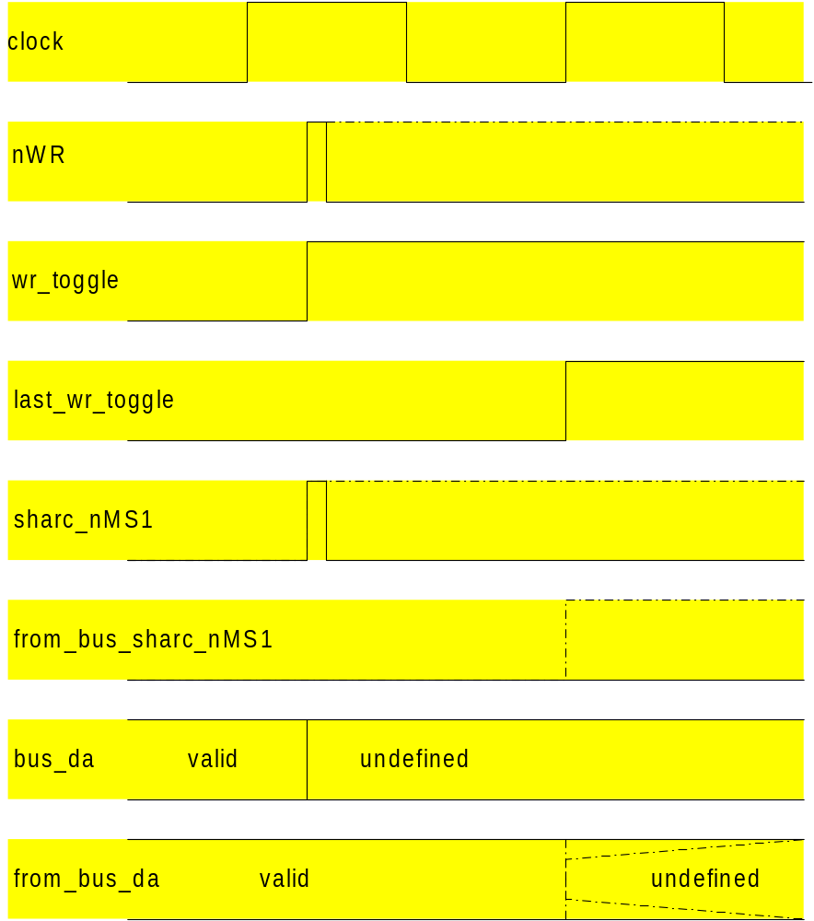

Figure 2: Timing of signals for write commands from the DSP, at the end of a single write command (dash-dotted line) and in the case where a second write command follows immediately after the first one (solid line). The figure follows the VHDL convention of not to show delta delays i.e. signal updates are shown without delay; equations evaluated at the rising edges of the clock take the values of the signals before that clock transition into account.
The rising edge of the nWR signal inverts the wr_toggle signal asynchronously. The value of wr_toggle is copied into last_wr_toggle on the rising edge of the clock and hence a difference between the two signals at the rising edge of the clock indicates that the nWR signal went high during the last clock cycle. The transition of the registered signal from_bus_sharc_nMS1 is delayed by 1 CC and in case of a immediately following next write it may even stay low. Data from the DSP is valid when the write strobe goes high and undefined thereafter. Data from the bus is copied into a register of the FPGA as long as the write strobe is low. This way, the register contains the data that was on the bus no more than 33 ns before, when the write strobe goes high. Using 2 wait states on the DSP side this procedure was found to be reliable.

For simplicity, the numbers for the 5MHz case (2*6 fold oversampling) are used explicitly here

